##### **A BRIEF HISTORY OF HOLY COMMUNION LAKE GENEVA**

Church of the Holy Communion is one of the oldest Episcopal parishes in Wisconsin – services began in 1844 in Bloomfield Township, WI. We moved to our current Lake Geneva location, two blocks from the lake, in 1880. The first services were conducted by the Right Reverend Jackson Kemper, the first Episcopal Bishop in Wisconsin until the arrival of Fr. John McNamara on September 29, 1849. The church was named in honor of the Church of the Holy Communion in New York, the parish of Fr. John McNamara.

###### Jackson Kemper: 1789-1870

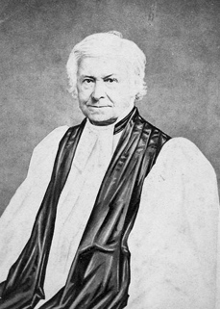

###### John McNamara: 1821/1824-1885

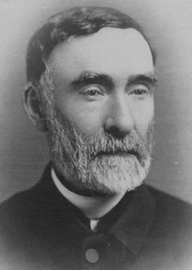

"One of the most interesting residents of Lake Geneva during the middle of the 19th century was the priest who came to Lake Geneva to serve as our first priest, John McNamara. He was born in either 1821 or 1824 in Ireland and was brought to the United States as an infant. He was adopted in New York City by the Rev. William Augustus Muhlenberg, an Episcopal priest who educated John. There is a memorial plaque on the west wall of the sanctuary that McNamara donated in honor of his mentor, the Rev. Muhlenberg.

McNamara studied theology at the General Theological Seminary in New York City and became an Epicopal priest. He preferred to be a missionary priest and was sent from New York City west to the village of Lake Geneva in 1850 at the age of 26 where on Jan. 20, 1850, he founded the Church of the Holy Communion.

Prior to his arrival, the Episcopal community in Lake Geneva, which had been organized in March 1844 in Bloomfield Township, was served by Episcopal priests-in-training from the Nashotah Seminary in Delafield. McNamara named the Episcopal Church in Geneva that he had founded the Church of the Holy Communion in honor of his home church of that name in New York City.

Father McNamara had published the first newspaper to appear in Lake Geneva, the Geneva Express. One page of the paper was titled the Anti-Slavery Churchman as McNamara was an abolishinist. As a missionary priest, McNamara served on the Kansas-Missouri border, but frequently returned to Holy Communion to serve there as well.

McNamara's years in Lake Geneva were very productive. In 1857, he arranged to have the wooden building of the Presbyterian Church (later the First Congregational Church) moved west across Broad Street to become the first building of the Church of the Holy Communion. He supervised the construction of the church's first permanent building at the northwest corner of Broad and Geneva streets on land that the church had purchased.

In 1861, when the Civil War began, Father McNamara enlisted in the 1st Wisconsin Regiment of the Union Army as a chaplain and served as a chaplain in the Union Army throughout the entirety of the war. McNamara's account of the well-known Battle of Chickamauga (in Georgia), Sept. 19-21, 1863 in which his regiment fought, remains one of the best accounts of the battle - the Civil War's second-bloodiest.

After the Civil War ended, Father McNamara briefly returned to the Church of the Holy Communion as its rector. However, he was soon assigned to serve as a missionary priest in various towns in Illinois, Missouri and Nebraska. He became especially well known because of his book "Three Years on the Kansas Border," which was first published in 1856 (and republished in 2015). Father McNamara was an ardent champion of the anti-slavery cause in Missouri and Kansas, just as he had been the most fervent anti-slavery proponent in Lake Geneva during the decade preceding the Civil War.

He died of a stroke on Oct. 24, 1885 in North Platte, Nebraska, where he had been serving as the rector of the Church of the Holy Savior.

He was 61 years old. His body was returned to Lake Geneva for burial in the Pioneer Cemetery, adjacent to the graves of four of his children who had predeceased him (Annie, Louisa, Mary and Archie).His grave is just north of the large tombstone for Dr. Philip Maxwell's grave. At his death, he was survived by his wife, Sarah, three daughters, Elizabeth, Sarah, Caroline and a son, Arthur. His wife died in 1911 and was buried in Fremont, Nebraska.

In various of his obituaries, Father McNamara was praised as being "progressive" in his views, and as someone who always did what he considered to be "the most good for God and humanity."

Although today unknown by most residents of Lake Geneva, Father John McNamara was one of the most interesting, accomplished and significant residents of Geneva during the middle of the 19th Century.

And we, at Holy Communion are grateful for all that he did for our Episcopal Church and the community at large.

***Source:*** *Patrick Quinn, Lake Geneva native who is the University Archivist Emeritus of Northwestern University, published in Lake Geneva Regional News, Oct. 2, 2019*

##### **THE CHURCH**

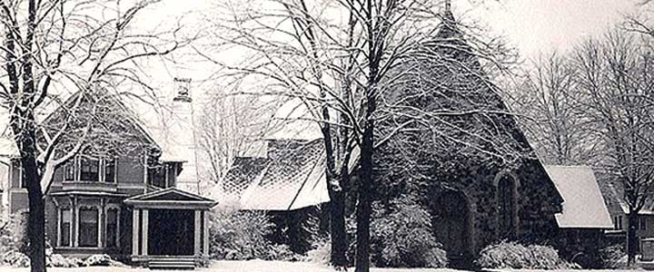

In 1857 the present site was purchased. The architectural firm of Treat and Folts in Chicago designed the building. Construction began on the church and a rectory on the adjoining lot west of it. On June 7, 1882, the Bishop of Milwaukee consecrated the new Church of the Holy Communion. Three days of consecration rites followed with a special train of guests coming from Chicago to attend the celebration.

The church is of gothic design with walls of native granite boulders, which were split and laid up irregularly to show a clean front and give the effect of changing colors and design.

The windows and coping of the steep roof are bordered with limestone, and the forty-three foot high interior is buttressed with oak beams.

##### **THE ORGAN**

Our Organ has a rich history in Lake Geneva, originally gifted to the church on June 12, 1883 by Mrs. George Mary Delafield Sturges. It has provided music at many Sunday services, weddings, recitals, funerals, and concerts over the past 135 years. In 2014, it was determined that our organ needed restoration and its 50-year-checkup – the last refurbishment being in 1969. Holy Communion is a small church but over five years managed to raise the $60,000 needed to have the organ restored. The final push involved several concerts, fundraisers, and even a 50/50 raffle to reach the goal. In January 2019, the organ restorer dismantled the organ and moved it to their facility in Champaign, Illinois. The renovation was more extensive than planned and took four months with re-installation in early June 2019.

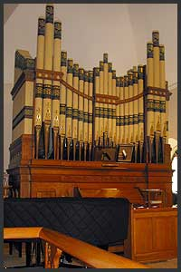

A little more history: The organ in the Church of the Holy Communion is a two manual and pedal, mechanical action organ with 11 ranks. It was installed in 1883, as the Opus 1144 of the Boston, Massachusetts firm of Hook & Hastings. The cost to completely replace it with an all-new instrument of similar size would be $500,000. But replacing this organ with a similar instrument could be three times that amount.

###### Mary Delafield Sturgis: 1842-1901

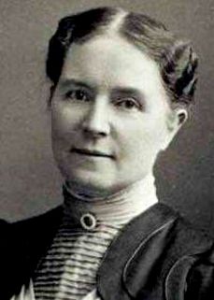

Mary Delafield Sturgis (1842-1901) married George Sturgis in 1862 and they would have nine children, six who would survive into adulthood. Mary Sturgis was a member of The Church of the Holy Communion and was key in raising funds for the church to be built. Besides donating her summer cottage and the land to be the Lake Geneva Library and Library Park, Mrs. Sturgis donated the church’s baptismal font in memory of their daughter, Julie Floyd Sturgis (1879-1881) who died at age two. She also donated the Hooks and Hastings Pipe Organ in memory of their son, Wallace Delafield Sturgis (1863-1887) who died at age 23. Her philanthropy and good deeds are still remembered by the people of Lake Geneva and especially the people of Holy Communion.

Hook & Hastings was founded in 1829 and was the preeminent New England organ builder of its day. Their instruments were truly world-class throughout the firm’s existence, and the remaining Hook organs are to be treasured as supreme examples of the organ builder’s art.

**Organ Restoration work completed in 2019:**

* Replacement of the wooden wind reservoir which serves as a pressurized chamber storing air to be distributed to the seven windchests that in turn feed the pipes. The organ was not able to have all the stops pulled to play at the same time, it can certainly do that now!
* The great manual windchest (wooden) had a crack in it, likely caused by low humidity. It is directly connected to the pipes themselves. This defect caused ciphers, or unwanted sounds. The windchest was removed, restored and reinstalled.

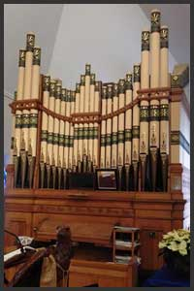

* Cleaning of pipework and fitting of necessary slide tuners and regulating rings. Much of the organ’s moving parts are wood and metal tie-rods resting on leather bushings and connected to leather valves. The leather had dried out over the years and has now been replaced. Some of the larger pipes would not hold a tuning because of this the organ required repeated tuning, especially before major events.
* Fabrication and installation of internal tuning slides on flue pipes and removable cap rings on Oboe-Bassoon pipes, to allow tuning of the organ to A-440 standards. The organ was originally built to A-450 in 1883. The American music industry reached an informal standard of 440 Hz in 1926. In 1936 the American Standards Association recommended that the A above middle C be tuned to 440 Hz. This alteration allows the organ to easily accompany many musical instruments.

Holy Communion’s organ is a classic that has been used for many organ recitals over its lifetime. We look forward to continuing to share this local treasure with musicians and concert goers of the future!

##### **THE WINDOWS**

Perhaps one of the most outstanding features of our church is her Gothic stained glass windows. Some of the windows were designed by the architect and executed in Munich, Germany by the Franz Mayer Company, which is still in existence.

**The Altar and Window**

On the left side of the altar is a window with the words, "Jesus Wept" and under it, "In memory of Graham Fairbanks, Born in January, 1867 and died in September of the same year, a child of nine months". He was the son of Helen and Nathaniel Fairbanks, early Lake Geneva residents.

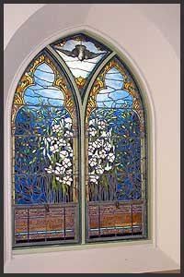

The Fairbanks name is also associated with the window on the left side of the altar by the words, "It is well" in the memory of Wallace Graham, Lt., USN. He was a 32 year old Naval officer.

Above the High Altar, the words are: "Ye do show the Lord’s death ‘till he comes," with the cross and crown above it. This is clearly a reference to the Eucharist and was installed during the time of the first rector.

The third window in the sanctuary has lilies and is given in memory of Rev. Isaac Marks, Jr., the 13th rector. He was born in New Orleans of a Jewish family. At some point he embraced Christianity and the Anglican Church. The lilies are primarily the symbol of the Virgin Mary, her virginity and chastity.

Tucked in on the side of the organ is another window, which reads, "Blessed are the Pure in Heart."" with what appears to be lilies on one half and morning glories on the other. Morning Glories are quite unique in that they are universal, growing on every continent, in almost every climate, and they fold up every night to rest and appear again the next morning. Their tendrils remind us of Jesus’ words, "I am the vine and you are the branches".

**Windows — East Wall**

The first window is dedicated to children, "For of such is the Kingdom of Heaven."" The figure is a child and an angel. The donor was Henry Lord Johnson, and it appears to have been done by the same firm, Mayer and Co., Munich, as is the window on the opposite side of the church. The design and artistry of both is exquisite. A comparison between the Mayer window on the East side and its opposite on the West side is subtly discovered in the upper center of the window. The East window focusing on children has the Greek letter "A" (Alpha) meaning "beginning" while the window on the west side has the Greek Omega meaning "end". In the east window the children reach out to the Guardian angel for protection and guidance. We see it in the purity of the children.

The next two windows honor one family and refer to death and one’s faith: "Blessed Are the Dead."" It is dedicated to Dr. Phillip Maxwell and his wife, Jerusha. The use of the Passion Flower as symbolic of the family is interesting. On the medical level, the leaves of the Passion Flower were used as a sedative and nerve tonic going back 200 years. As a sacred symbol, the Passion Flower is symbolic of the Passion of Christ. The 72 filaments were the number of thorns in His crown. The three stigma are the nails and the five stamens are the number of wounds He suffered. The leaf represents the spear that made the wound on Jesus’ side. The black spots under the leaves are the 33 pieces of silver paid to Judas.

The adjoining window bears the inscription, "He Giveth His Beloved Sleep In memory of Ophelia Maxwell Walter". Ophelia was the daughter of Dr. Maxwell.

**The Trinity ("Rose") Window**

The large Trinity Window in the rear of the church is the symbol of the Blessed Trinity exhibiting three circles connected by bands forming an equilateral triangle. In this symbol we are going beyond words as defining God. Such a window is unique in that it is quite rare to find a Trinity Window in a church this small. It is unmarked, as are the two lancet windows at either side below. However there is a recent plaque that goes with the Trinity window. It was discovered to be in very bad repair and two current parishioners gave the money for the repair and dedicated the window to their grandmothers.

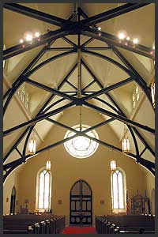

**The West Wall**

On the rear window we find symbols of an anchor and a pelican with the words, "In memory of Betsy William Richardson, a Beloved Wife, Mother and Sister." The anchor and the pelican are two ancient symbols of the Christian tradition. The anchor is found in the catacombs as a sign of the fixed hope of Christians. The pelican symbol of motherhood arising from Psalm 102 which says in our translation, "I have become like an owl in the wilderness"…but since Hebrew has no vowels, it was written, "Like a pelican in the wilderness." This is based on the excessive devotion of the mother pelican described by medieval writers as typifying the love of Christ. The mother pelican will wound herself in time of famine by striking her breast with her beak, and as the blood emerges her children are fed by her own life. Given this legend it is easy to see why the early Christians adapted the symbol and applied it to Christ who sheds his blood for us. We who were dead to sin have new life in the body and blood of Christ in the Eucharist. This symbol is especially significant because the name of this parish is "The Church of the Holy Communion." Together these two symbols are outstanding symbols of motherhood.

Our next window is the Lamb of God, dedicated to the memory of Kate Louise Keyes, a child of five years at the time of her death. The Lamb is one of those ancient and persistent symbols in the Christian lore dating back to the fourth century. It was the mark of Passover to take blood from lambs and smear it on the doors of Israelites to protect their children from the angel of death. The symbol of the palm in the adjoining window signifies praise, triumph and thanksgiving. God himself ordered them to be carried. The Lord spoke to Moses and said, "…on the first day you will take the fruit of the majestic trees, BRANCHES OF THE PALM TREES…and you shall rejoice in the Lord for seven days" (Leviticus 23:40). Palms were also borne in honor of our Lord in his majestic entrance on Palm Sunday.

The last window on the West with the Omega at the top is a companion to the Alpha window on the east. This has a more mystical and complicated quality about it. Abraham, the "Father of Believers" and King David are portrayed. David holds a lyre and wears a crown. King David lost his son, Absolom, in battle with his own father. His grief over the rebellion and the loss of his son are contained in the famous words, "Absolom, my son Absolom, would I have died in place of you, O Absolom, my son, my son." In the left panel of the same window we see Abraham with the dead ram offered as sacrifice in place of his son, Isaac. The knife lies at his feet. The Psalm verse, "Do not cast me off in my old age, forsake me not when my strength fails" takes on a special meaning.

On the South side of the transept there is a set of windows given by Fr. Marks in memory of both his wife and daughter who preceded him in death. They are buried in Oak Hill Cemetery, Lake Geneva.

The final and last window is our most famous one because it was designed by Louis Comfort Tiffany. It features a dove, lilies and scenes of nature. There are no signatures on the window to prove its authenticity as a Tiffany window, but a long oral tradition in the parish says it is. Several stained glass authorities have said that it has all of the style and colors of a Tiffany.

##### **PLAQUES**

In the entry to the right are two plaques. One is for William Augustus Mulenberg (1796-1877) a leading Episcopal priest of the 19th century, a proponent of Catholicism in the Anglican Church and a great influence on both Bishop Kemper, the first bishop of Wisconsin and Fr. John McNamara, the first rector of The Church of the Holy Communion.

##### **STATIONS OF THE CROSS**

The Stations of the Cross were carved in Obergammerau, Germany, which is the home of the world famous Passion Play, and were installed in the church in the early 1960’s.

##### **THE KNEELERS**

The kneelers at the altar rail were made by the women of the ECW and presented to the church in 1991. It was a labor of love that took nine years by the twelve needlepointers, most of whom had to learn the art from scratch. The project was chaired by Dottie Swanson who also designed many of the cushions. Each cushion has a sponsor and the cost was also shared by sponsors and given in memory of loved ones.

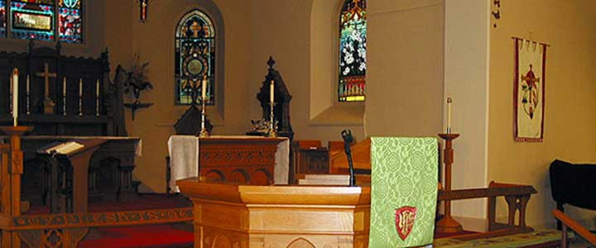

* THE CHRISTMAS KNEELER: Mary with the Baby Jesus, the Nativity Angel, robed in red to symbolize Joy, the three Wise Men, the Star, and a shepherd with a lamb.
* THE EASTER KNEELER: The lilies symbolize the Glory of the Risen Lord and new eternal life. The crown and cross symbolize the reward of the faithful in life after death. It was inspired by the stained glass above the High Altar.
* THE APOSTLE’S KNEELER: The Winged Ox symbolizes St. Luke, Christ’s sacrifice and atonement. The golden cross inset with jewels is a depiction of the Processional Cross used every Sunday. The gold is the symbol of pure light and the rubies of the wounds Christ suffered during crucifixion. St. John is seen in the Eagle representing the ascension and divinity of Christ.
* THE CHILDREN’S KNEELER: The five loaves and two fish represent the boy’s lunch that was used to feed the 5,000. The Fish is the symbol of Christ and the loaves of the Bread of Life. The lion and lamb lying down together represent the peaceable kingdom that will prevail under Christ’s rule. Noah’s Ark is an ancient baptismal symbol. The Dove with olive branch means the waters had receded from the earth. The Rainbow represents God’s Covenant with Noah.
* THE NATURE KNEELER: “Wildflowers, God’s own needlepoint.” Here are some of the wildflowers of Wisconsin. The butterfly symbolizes resurrected life. The stag symbol is taken from Psalm 42:1, “as the deer longs for the water brooks, so my soul for you, O God.” Thus it is the symbol of Solitude and Purity of Life. The trees are the sentinels that once stood around this church — the oak leaves and acorn for Faith, Remembrance and Endurance.
* THE HISTORY KNEELER: Chief Big Foot stands looking over Lake Geneva. Williams Bay and Yerkes Observatory, Church of the Holy Communion and the Lady of the Lake are also depicted. At the right is Fr. McNamara, the first rector of this church.
* THE COMMON KNEELER: One of the most vivid symbols of the Bible is the grapevine. The grapes symbolize the wine of the Holy Communion. The engraving, IHS on the silver challis are the first three letter of IHSUS, the name of Jesus in Greek. The Prayer Book is open to the Ten Commandments.
* THE TRINITY KNEELER: The Alpha and Omega are the first and last letters of the Greek alphabet, signifying that Jesus is the Beginning and End of all things. Chi Rho (XP) are the first two letters in the Title Christ, representing Christ as the reigning and triumphant Messiah. The fish is the symbol of Christ and Baptism. The Open Hands portray God the Father and His creative power in the world. The Descending Dove reminds us of the presence of the Holy Spirit.
* THE MUSIC KNEELER: The Golden Harp is the symbol of David and the Book of Psalms and all music in the honor of God. The lute, trumpet and lyre, are the instruments of Biblical times. The Pipe Organ symbolizes the continued praise the Church offers to the Glory of God.
* THE APOSTLE’S KNEELER: The angel represents St. Matthew who presents Christ to us as King. Next, an interpretation of the Celtic cross with the circle of Eternal Life. The Chi Rho symbol of our Lord is in the center of the cross. The winged lion is the symbol of St. Mark representing the majesty of Christ. (The worker of this kneeler counted 66,615 stitches for its completion.)
* THE BISHOP’S CUSHION: This shows the Episcopal Shield on the left. The center design is the Diocese of Milwaukee Bishop’s Emblem, and to the right is our own Holy Communion Episcopal Church emblem.
* THE DESCENDING DOVE CUSHION: The Descending Dove symbolizes God, the Holy Spirit, who descended upon Jesus at His baptism.