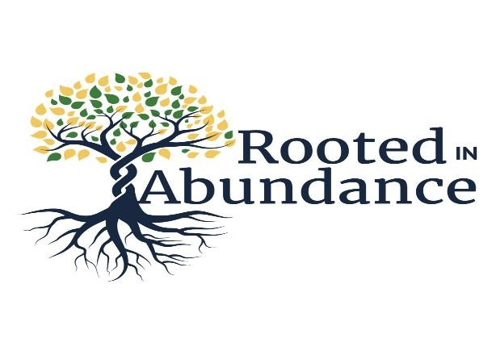
They shall be like a tree planted by water, sending out its roots by the stream. It shall not fear when heat comes, and it’s leaves shall stay green; in the year of drought it is not anxious, and it does not cease to hear fruit. Jeremiah 17:8

November 12, 2023

Dear friends -
This year’s Stewardship Campaign, “Rooted in Abundance,” reminds us of how deep our roots are here in Walworth County, and how often God has used us to bring hope and healing to the world. Jesus reminds us that he came so that we might have life, and have it abundantly and, daily I experience the abundance of riches we have here in Wisconsin: clean air, clean water, abundant agriculture, and a healthy economy.
This year, thanks to your support, our parish was able to give generously to many local charities including: Side-by-Side, The Open Arms Free Clinic, the Walworth County Diaper Project, and the Lake Geneva Food Pantry. We also donated to the Diocesan Haiti Project and improved the safety and integrity of our beautiful building. This year, we improved the safety of our entrances, added a new heating system, and began restoring our beautiful stained-glass windows. Thank you for your generosity.
This year, as all churches try to recover from the COVID-19 pandemic, I boldly ask you to examine your support of Holy Communion Episcopal Church. God loves a cheerful giver. (2Cor 9:7) Ask yourself not only about what you will give but about the attitude with which you give it. Do you give from what’s left over or do you give from your first fruits? While the biblical standard of giving is the tithe (10%) few Christians give at that level, but we maintain it as a goal. Look at the Proportional Giving table attached to your pledge card and determine what percentage of your wealth you offer to God. Is it 2%? Is it 4%? This year, please pray about increasing your level of giving by just one percentage point. Doing so will be an investment in the future of our congregation and you will see how generosity spreads and widens our root structures of faith and action.
Join me in making 2024 a year that is rooted in abundance as we continue to bring hope, care, and compassion to our little corner of God’s Kingdom. Please accept my thanks for all your past support, and for your ongoing generosity.
Gratefully,

The Rev. Elizabeth Gordon Meade, Rector

The episcopal church of The holy communion
320 Broad sTreeT – lake Geneva, Wisconsin 53147
holycommunionlakeGeneva.com

